

The University of Azad Jammu and Kashmir,
Muzaffarabad

Name | Kamal Ali Akmal
Course Name | Operating System
Submitted to | Engr. Daniyal Nazeer
Semester | 3rd
Session | 2024-2028
Roll No | 2024-SE-38
Lab No | 04
Submission date | 14 November 2025

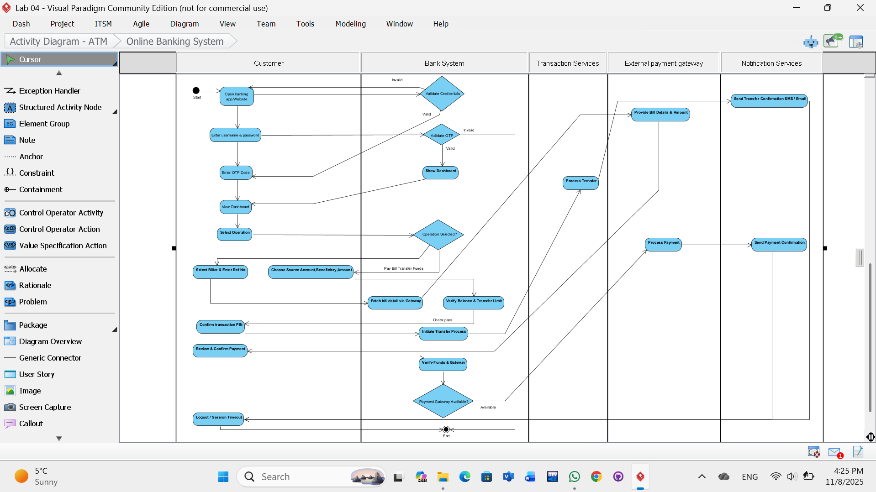
UML Activity Diagram for Online Banking System
Key Explanations:
- Swimlanes: Each column represents a different actor from my list, showing who performs which action.
- Start/End: The process begins at the "Start" node and can end after logout, session timeout, or a failed login/OTP.
- Decisions (Diamonds): These represent points where the flow can branch based on a condition (e.g., Validate Credentials, Operation Selected?).
- Fund Transfer Path: This path shows the specific steps for transferring money, including balance checks, PIN confirmation, and updating the database.
- Bill Payment Path: This path shows the steps for paying a bill, which involves interacting with an External Payment Gateway and handling its potential unavailability with a retry mechanism.
- Notifications: Both workflows conclude with the Notification Service sending a confirmation message to the customer.

